1. Find the surface area of the prism below.

4.5 in
6 in

3 in

2. The cylinder below represents a can I found in my pantry. Find the surface area of the label to the nearest tenth of a square meter of the cylinder below.
4 in

5.5 in

3. Find the volume of the rectangular prism below.

9 cm

4.5 cm

4 cm

4. Find the volume of the cylinder below. Round to the nearest tenth.
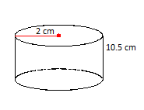

5. Find the volume of the cone below.

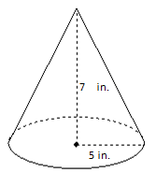

6. Draw all of the lines of symmetry on the figures below.

7. Draw the image of the figure after a clockwise rotation of 180º

8. using the triangle below (ABC), draw a reflection over the y-axis in box 1, draw a 90 degree rotation in box 2 and draw a translation over the x-axis in box 3
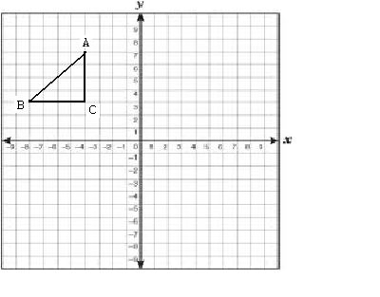
1

3
2

9. Draw the lines of symmetry on each of the following:
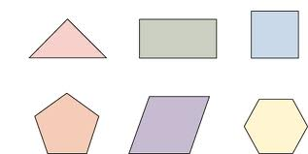

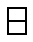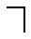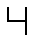

10. Looking at the net, what solid does it make? What is the volume of this solid? (hint: draw the 3-D view and that should help you solve this.)
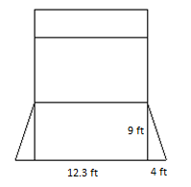

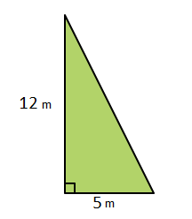
11. What is the area of the following triangle:

7 m

12. From the bottom, top, left, right, front and back view, how many cubes are showing? Draw and list each and answer.

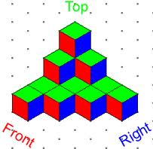
Bottom Top

Left Right Front Back

Use the following problem to answers question
13. Ms. Smith is moving and she needs to figure out which boxes to buy.
3 in
10 in
5 in
4 in
2 in
4 in

A) What is the volume of the smaller moving box?

B) What is the volume of the larger moving box?

C) How many times greater is the volume of the larger box compared to the volume of the smaller box? (hint: how many times will the small box fit into the big box?)

14. These are scale drawings of two cylinders. The shorter cylinder has a radius of 4 cm and a height of 5 cm. The taller cylinder has a radius of 3 cm and a height of 20 cm.
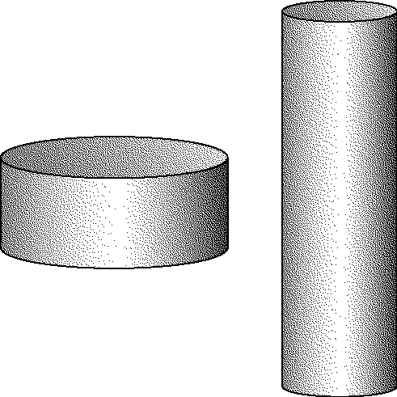

Do the cylinders have the same volume? What is the difference? Show your calculations.

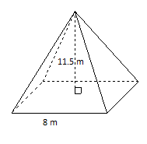
15. Find the volume of the square based pyramid below.

16. Jamie is building a square sandbox with sides 8 feet long and 6 feet wide. She wants to put sand 2 feet deep in the box. How much sand should Jamilla order in cubic feet?

17. A paper cup is a perfect cylinder that is 8 cm tall and 6 cm across. Find the total area of paper needed to make the cup, to the nearest square centimeter. (hint: the cup does not have a top so think of how the formula changes)

18. TCBY wants to see how much yogurt can fit in their Super Duper Cone. Help them find the volume of the cone below that has a height of 11 inches and a radius of 8 inches! Round to the nearest cubic inch.

For Problems below, find the AREA of the figure or the missing side
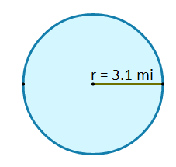
19. 20.
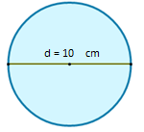

Find the Area or missing side of the shapes below

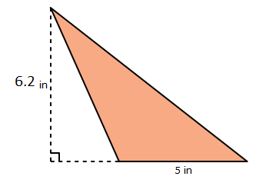
21. 22.
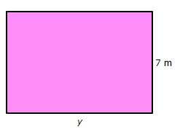
What is the missing length if the Area = 140 square meters?

7 in

Area = ______________________ y = _________

Find the SA and Volume for each of the solids:

23. Surface Area = __________________ Volume = _______________

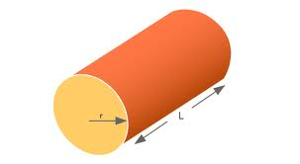
r = 4 yards

L= 9 yards

