Key
Standards Continue
Math 8

Key
Standards
Unit 7: Probability  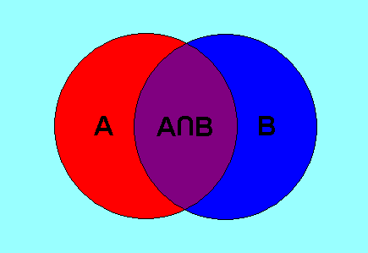 | MA.8.M8D1. Probability: Students will use and understand set theory and simple counting techniques; determine the theoretical probability of simple events. (PSAT M3) (ACT)  a. Demonstrate relationships among sets through use of Venn diagrams.  b. Determine subsets, complements, intersection and union of sets.  c. Use set notation to denote elements of a set.  MA.8.M8D2. Students will determine the number of outcomes related to a given event.  a. Use tree diagrams to find the number of outcomes.  b. Apply the addition and multiplication principles of counting. | MA.8.M8D3. Students will use the basic laws of probability.  a. Find the probability of simple independent events.  b. Find the probability of compound independent events.
Mon Tue Wed Thu Fri  3/12 Solving Systems of Linear Inequalities Holt 6-6 3/13 - Solving Systems of Liner Equations (Word Problems WS4) 3/14 -Unit 6 Review 3/15 Unit 6 Review (DAY 2) 3/16 -UNIT 6 TEST  3/19 Venn Diagrams Pg. 424 - 426 3/20 Set Relations Pg 427 3/21 - Ratio and Probability Pg. 246 - 250 3/22 Theoretical & Experimental Pg. 470 - 473 3/23 - Predictions and experimental probability Pg # 475 - 479  3/26 Independent Events Pg. 486 - 490 3/27 Permutation Pg. 491 3/28 CRCT Review 3/29 CRCT REVIEW 3/30 CRCT REVIEW  4/2 SPRING BREAK WEEK !!!! 4/3 4/4 4/5 4/6  4/9 CRCT REVIEW 4/10 CRCT REVIEW 4/11 CRCT REVIEW 4/12 CRCT REVIEW 4/13 Math CRCT |  | Vocabulary  Complement: The complement of event E, sometimes denoted E′ (E prime), occurs when E doesn’t. The probability of E′ equals 1 minus the probability of E: P(E′) = 1 – P(E).  Counting Principle: Suppose there are m ways of making one choice and n ways of making a second choice. Then there are m ·n ways to make the first choice followed by the second choice.  Dependent: Events that have outcomes which affect each other. For instance,if A anre dependent events, P(A, then B) = P(A) · P (B after A).  Disjoint: Two events are disjoint if they can't both happen at the same time (in other words, if they have no outcomes in common). Equivalently, two events are disjoint if their intersection is the empty set.  Element: A member of or an object in a set.  Empty Set: The empty set, Ø, is the set that has no members.  Independent events: Events for which the occurrence of one has no impact on the occurrence of the other.  Relative frequency: The number of times an outcome occurs divided by the total number of trials.  Sample space: All possible outcomes of a given experiment.  Event: A subset of a sample space.  Simple Event: An event consisting of just one outcome. A simple event can be represented by a single branch of a tree diagram.  Compound Event: A sequence of simple events.  Probability: The measure of how likely it is for an event to occur. The probability of an event is always a number between zero and 100%. The meaning (interpretation) of probability is the subject of theories of probability. However, any rule for assigning probabilities to events has to satisfy the axioms of probability.  Tree diagram: A tree-shaped diagram that illustrates sequentially the possible outcomes of a given event.

