1. **A slide at a children’s playground is 48 feet long. How long would it be on a scale drawing with a scale of 1 in = 4 ft? Solve this problem using a proportion.**
2. **The two parallelograms are similar. Find the missing length *x* in parallelogram B.**



x



1. **A piece of paper is 12 inches wide by 9 inches long. After it is cut for a project, the piece of paper is of similar shape, but it is only 4 inches wide. How long is the piece of paper after it is cut for the project?**
2. **A desk is 8 inches wide and 20 inches long. When the desk is pushed together with another desk, it creates a table. The table is 50 inches wide. How long is the table?**
3. **Ms. Gunning’s classroom has a total area of 20 ¾ square meters. She has decided to use desks to fill 1/3 of the classroom. How many square meters are being taken up by the desks?**







1. **Using the figures above, how long is side a?**
2. **According the figures above, how long is side b?**
3. **According to the figures above, what is the scale factor from the bigger triangle to the smaller triangle?**
4. **Ms. Powers made a scale model of her favorite restaurant. The actual width of the building is 50 feet, and the actual length is 65 feet. If the model has a width of 4.25 inches, what is the length of his model?**

**4 in.**



**10 in**

**SCALE: 1 in. = .8 feet**

1. **What would the actual height of the tree be?**







1. **Quadrilaterals ABCD and EFGH are similar. Which are corresponding sides?**
2. **Mary is a gardener. She plants carrots every 6 days. She plants tomatoes every 15 days. How many days will pass before Mary plants carrots and tomatoes on the same day?**
3. **On a map, the distance from Mr. Goodwin’s house to school is 5.7 inches. If the scale of the map is 1 inch = 8 miles, what is the actual distance in miles from Mr. Goodwin’s house to school?**
4. **The two triangles below have the following relationship: ABC ~ EFG**

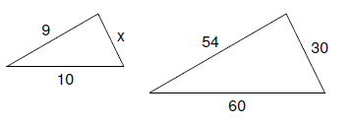







**What is the length of $BC$?**

1. **Ms. Springman wants to give each classroom another white board. If she has one white board that is 186 inches long, how many individual boards can she make if each classroom’s board needs to be 23 $\frac{1}{4}$ inches long?**
2. **A scale model of a baseball bat is 14 inches long. Use the scale to see how many feet long the actual bat is.**

**C:\Program Files\Microsoft Office XP\Media\CntCD1\ClipArt7\j0299755.wmf**

**SCALE: 1 inch = .25 feet**

**14 inches**

1. **Mrs. Huftalin bakes the kind of cookies shown below.**

|  |  |
| --- | --- |
| **Kind of Fruit Bar** | **Number** |
| **Sugar** | **133** |
| **Chocolate Chip** | **38** |
| **Oatmeal** | **76** |

**Mrs. Huftalin wants to make baskets of the cookies for her students, and she wants to divide each kind of cookie equally among the baskets. What is the greatest number of baskets can she make?**

1. **On a map the scale says that 1 inch = 8 miles. Ms. Fainter measures the distance from her house to the store on the map and it is 4.3 inches. How many miles is the store from her house?**
2. **The triangles below are similar. What is *x* if the side that corresponds to 16 cm is *x* and the side that corresponds to 22 cm is 11 cm?**

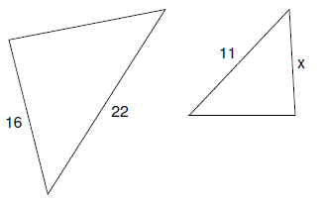

1. 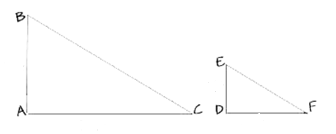**List the sides of the triangles that are proportional.**